**OBSERVATIONS AND PERFORMANCE OVERVIEW OF VIKRAM CEMENT WORKS POWER PLANT**

**Plant Overview : Vikram Cement Works Power Plant**

UTCL, Vikram Cement Works Power plant was commissioned in 2008. It is a part of Ultratech Cement Limited located in Neemuch, Madhya Pradesh. It is a 2x23MW Captive Power Plant with 2 water tube coal fired boilers, each with a 130TPH capacity.

Details of main equipment and DCS are given below :

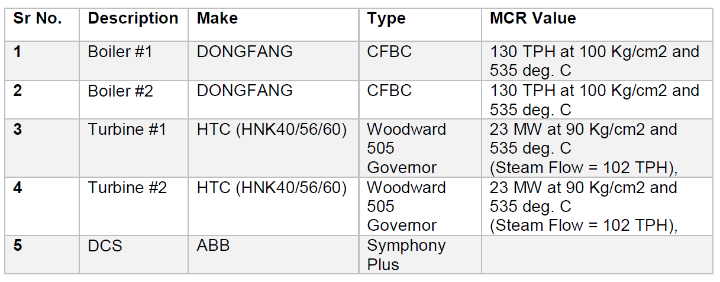

**Fuel used in the plant :**

Main fuel used in the boiler combustion chamber is a combination of Pet coke, Indian coal and Lignite. Here the measurement of coal flow is volumetric type. Composition

and heating value of the fuel is given below :

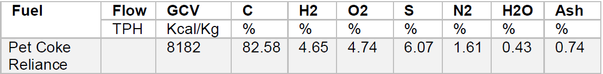

**Boiler overview :**

Each boiler has a 100 kg per sq.cm of working pressure along with a 540 degree Centigrade working temperature.Major Boiler equipment is listed below:

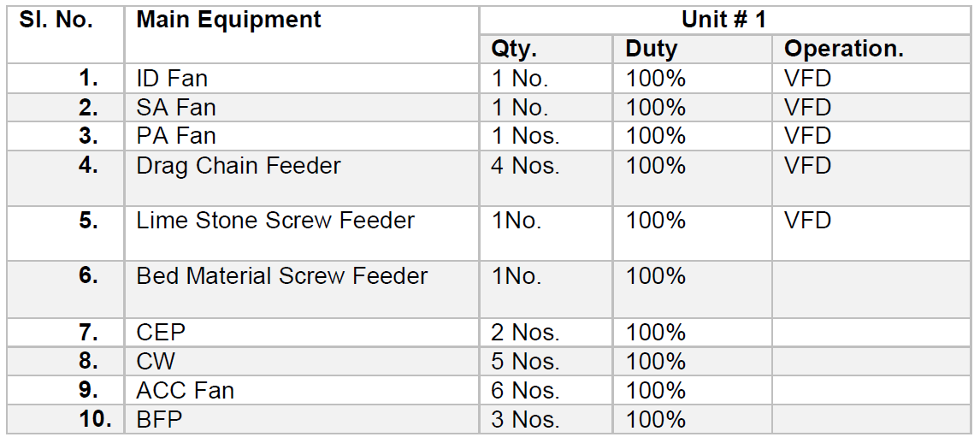

The plant uses CPP Boilers (Condensate Polishing Plants), that prevents steam condensate contaminants and corrosion products from entering the boiler or turbine. CPP Boilers in the plant are connected via a common header, but measurement of Common Header Steam Pressure is missing.

**Control Loops for combustion control :**

Major control loops employed in the plant and their designs are listed below :

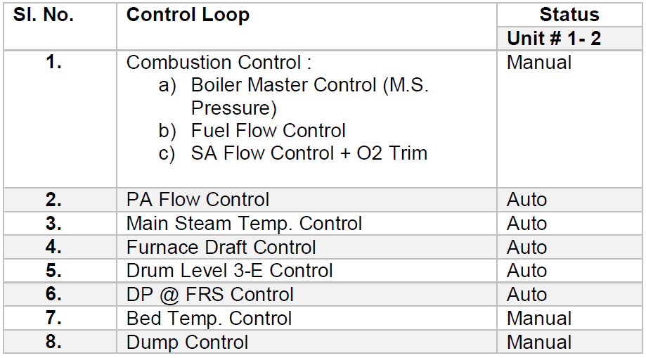

**OVERVIEW OF TPP PERFORMANCE IMPROVEMENT REPORT :**

We were provided an Opportunity Identification Report which detailed the current performance of the UTCL Vikram Cement Works Power Plant and identified opportunities for improvement and increasing efficiency. The report was based on a performance study conducted by ABB where plant performance data was recorded and analysed.

**HOW ABB CONDUCTED THE STUDY**

Before conducting a detailed study, a baseline for current plant performance was established. This was done to compare it against the new performance data that would be recorded after the suggested improvements were implemented. The baseline also helped in finding any deviations in design performance values for plant equipment and machinery.

ABB’s performance calculation software module was used to determine actual plant performance. The software assumes a fuel composition of 100%Pet Coke (with calorific value of 8182 kcal/kg), mixed with 30-40% limestone used as boiler feed. Control logic software was also used to track how present controls were configured.

The actual plant performance was then recorded for 2 different units of the plant to establish a baseline

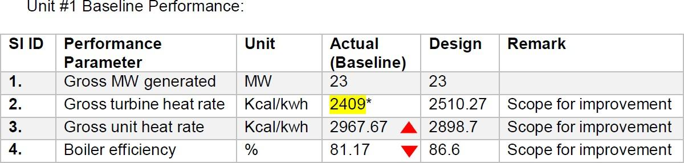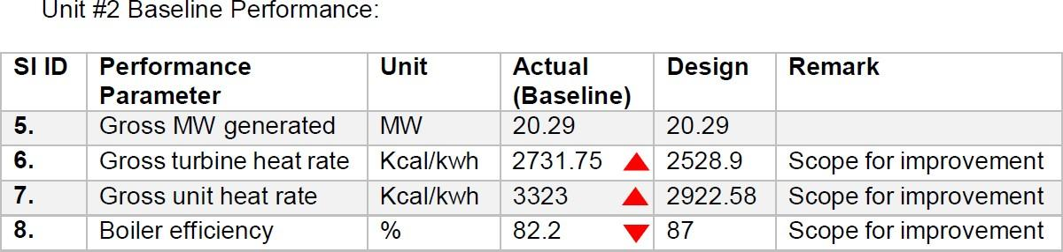

This baseline was first compared with the set design parameters and then with actual data that was collected during site visit.

**CONCLUSIONS THAT WERE DRAWN FROM THE STUDY :**

The performance report suggested over a dozen performance improvement opportunities for UTCL Vikram Cement Works Power Plant. The report also suggested improvements for few control logics along with their prospective benefits.

Estimated improvements of implementing suggested solutions are listed below:

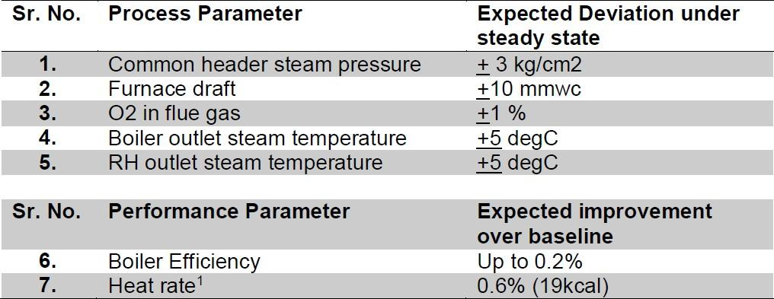

A few benefits of implementing suggested solutions include:

1. Improvement in heat rate due to reduction of fuel consumption per unit of energy
2. Increased Boiler efficiency due to combustion optimization
3. Faster equipment response to load disturbances
4. Reduction in energy consumption by equipment such as ACC fans.
5. Reduction in excess O2 consumption
6. Improved emission and operator efficiency

**FEW OBSERVATIONS :**

After carefully reviewing the industry report, we made a few observations that were in alignment with our study of Thermal Power Plants, APC and Auxiliary Power Consumption.

1. No control loop exists for coordinating boiler and turbine operations. This can cause problems during variations (such as changes in fuel composition or leakages) and disturbances during operation. Lack of a feedback mechanism means boilers and turbines operate independent of each other and any variation in one doesn’t affect the operational parameters of the other. An APC on top of existing control loops can help coordinate operation of both.
2. There is no continuous performance monitoring of the plant. Any deviations in current and design performance like heat rate, efficiency, etc are not recorded and hence the operator remains unaware of any corrections that must be made to current operational modes. A performance monitoring and reporting system can help in fine tuning of machinery and equipment during operation.
3. Furnace pressure control is not optimized which leads to higher auxiliary consumption by PA and SA fans. An Advanced Controller with feedforward for the individual VFDs can help optimize power consumption by PA and SA fans.
4. The current control loops didn’t take into account any changes in fuel quality/composition or variations in combustion conditions. Advanced Controller for fuel feed can improve and provide stable response to air and fuel feed. This model can tune fuel feed parameters so that the combustion cycle adjusts to any changes in fuel type/composition. Also it can fine tune fuel feed based on GCV of fuel composition.

**AUXILIARY POWER CONSUMPTION :**

Power generation capacity of a Thermal Power Plant also depends on the power consumed by its machinery and equipment. To keep the plant operational, certain source of electric power is needed to drive equipment and their auxiliaries. This power requirement is fulfilled by the plant itself. Out of the total power generated by the turbines, some part of it is lost as the power consumed by the plant equipment. This is known as auxiliary power consumption, that is the power consumed by plant equipment and its auxiliaries.

Auxiliary power consumption of a plant typically lies within the range of 8 to 10%, with variations occurring overtime due to aging equipment.

Major equipments consuming auxiliary power are :

1. Boiler Feed pumps
2. ID fans
3. PA fans
4. SA fans
5. ACC fans
6. Pulverizers
7. CWF pumps
8. Electrostatics precipitators

Percentage wise distribution of auxiliary power consumption of Vikram Cement Works Power Plant for the year 2018-19 is given below :

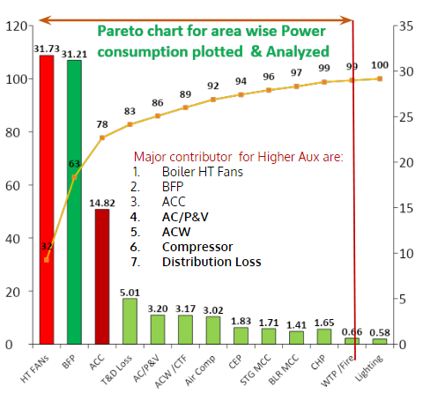

**CHANGES IN AUXILIARY POWER CONSUMPTION :**

Auxiliary power consumption varies over a limited range but deviations are observed over a long period of time. It affects the overall efficiency of the plant considering an average 8% consumption value, but it also indicates degrading machine cycles or faults in the pipeline due to increasing age of equipment and machinery.

Power consumption increases with the passing lifespan of equipment due to increased thermal stress or deterioration due to disturbances in the operation cycles. Major factors that can increase power consumption are :

1. Air leakage into the boiler gas enclosure can decrease the temperature within the boiler combustion chamber and can create an unsuitable combustion environment for the fuel.
2. Deterioration of boiler heating surface. This decreases heat rate and causes higher dry gas loss.
3. Higher draft loss due to air ingress and ash deposition.
4. Deterioration of generator stator windings due to increased stress and age
5. Deterioration of Turbine Steam Path Condition.
6. Condenser pressure/ condenser cleanliness affected due to air ingress and extent of tube pluggage. Contamination of feed water can cause changes in heat capacity, that indirectly affects boiler efficiency
7. Steam and water leaks from drains and vents.

The factors listed all point towards increasing thermal stress that leads to increased load on equipment and its auxiliaries. This causes an increase in power consumption with the goal of maintaining optimal operational conditions.

**PLANT LOAD FACTOR :**

Auxiliary power consumption can be quantified for analysis and comparison with the use of plant load factor. Many of the Indian power stations are operating at sub-optimal plant load factor that cause higher auxiliary power and decreased efficiency and performance.

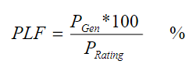

Instantaneous plant load factor is given by :

Whereas auxiliary power consumption of individual components can be calculated using 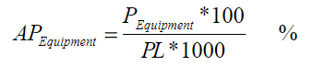

:

Since auxiliary power is essential to keep the plant operational, there is no scope of nullifying power consumption of equipment and machinery. Instead any deviation in power consumption can be used as a control parameter to identify areas with increasing power demand and help in optimizing the overall power consumption. The formula for deviation of AP of individual components is :

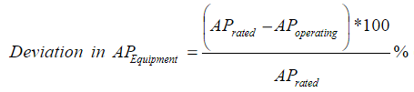

A few areas that can improve the plant load factor include :

1. Quality of coal used - higher calorific value and low ash content coal reduces the flue gas flow, which decreases stress on ID fans.
2. Boiler efficiency - increased boiler efficiency reduces stress on BFP, PA fans and SA fans.
3. Turbine efficiency - increasing turbine efficiency ensures reduced stress on CWF pumps and alternator windings.
4. Regular maintenance of BFPs and heating valves to ensure corrosion and other deterioration parameters are within acceptable ranges.

**REDUCING AUXILIARY POWER CONSUMPTION :**

Few steps to reduce auxiliary power consumption are listed below :

1. Consider Variable frequency drives for Boiler feed pumps, fans and other major Auxiliaries. Manual operation of BFP control requires a wide tolerance range, which leads to excess power consumption than required.
2. Choose optimum margins on head and flow for Boiler feed pumps and fans, to attain best efficiency under actual operating conditions.
3. Boilers with best possible efficiency should be used that allow optimal combustion environment along with automated control loops to keep power consumption within specified tolerance range
4. Leak proof duct design to avoid air ingress in order to reduce load on induced draft fan.
5. Ensure complete combustion in furnace, so that required steam generation can be achieved with optimum fuel quantity.
6. Minimise system drop (flue gas side , steam and water side) without affecting the Boiler performance.

**CONCLUSION :**

The project mainly focuses on Thermal power plants efficiency and the factors affecting it. It presents the factors that affect the efficiency, while also presenting areas of improvement along with their prospective benefits. To achieve this an understanding of basics of thermodynamics and power cycles, with specific focus on Rankine cycle is required, which is also presented in this report. Much of the study draws assumptions/hypotheses that are later compared and verified against actual industrial data provided by the PS-1 station (Vikram Cement Works).

The project dives deep into the topics of Advanced Process Control (APC) and latest technologies, while also detailing various factors such as auxiliary power consumption that affect the overall efficiency of a thermal power plant. The data presented is derived from industrial reports and sources online. This availability of industrial data compensates for the lack of an actual industrial visit caused due to the Covid pandemic.

Overall the project aimed at improving the thermal power plant efficiency and performance. The main objectives of this project were to identify areas of improvement, suggest solutions for existing problems and present new technologies that can be utilised by thermal power plants to compete in a market where renewable energy sources are becoming more dominant.